Exhibitor Information Submission Guidelines

Exhibitor Information Submission Guidelines
(*Fields marked with * are required)
To increase exhibitors’ exposure in overseas markets and help your company generate qualified business opportunities before, during, and after the exhibition, the organizer will promote the information you submit through multiple official channels.

Please make sure to complete all required fields accurately, as the information will be used in the following promotions:
1. Overseas Social Media Promotion (Official Posts)
The organizer will promote exhibitors through official posts on major international social media platforms. The content may include:
- Introduction to your company’s main business and core products
- Highlights of your products or solutions
- Official website link
- Official social media accounts (for tagging)
This helps overseas buyers and potential clients quickly understand your business and easily contact you through your website or social media profile, improving brand credibility and inquiry conversion.

2. Exhibitor Listing on the Official Website (Key Visitor Search Channel)
The exhibitor list on the official exhibition website is an important channel for visitors to find potential partners before, during, and after the event. Each year, many overseas visitors actively search the website for companies that match their purchasing or cooperation needs.
The organizer will display the submitted company and product information on the website exhibitor list, helping visitors to:
- Quickly find relevant products and services
- Identify and connect with target exhibitors
- Start communication before the exhibition and improve on-site meeting efficiency
Complete and clear exhibitor information will significantly increase the chances of being searched, viewed, and contacted by potential buyers.

1. Company Name *
Chinese Name:深圳市必应电子标签有限公司
English Name: Shenzhen Bingrfid Co., Ltd.
Website Link: www.bingrfid.cn

2. Booth Number *
Booth number:9D46
3. Company Logo *
(AI source file or high-resolution image)
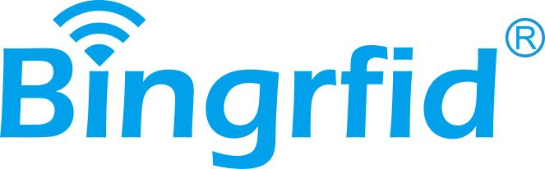
4. Company Introduction (English) *
Shenzhen Bingrfid Co., Ltd. is a professional service provider specializing in the perception layer of the Internet of Things. We have been focusing on the fields of smart cards, NFC tags and RFID electronic tags for many years. We are a practical enterprise integrating R&D, production and sales. With core products that are highly adaptable, of high quality and offer good value for money, we provide product solutions for IoT perception in various industries. Our products are widely used in multiple scenarios such as logistics, retail, healthcare, security, industry, and office, serving over a thousand enterprise customers. With our strong product capabilities, we have gained unanimous market recognition.

5. Main Business *
(No word limit)
Our main products are applied in numerous fields, such as member consumption, admission tickets, asset management, warehousing and logistics, identity recognition, inventory tracking, anti-counterfeiting traceability, etc. Through our radio frequency identification products, we have met the demands of many industries for data collection, security, accuracy, convenience and efficient management.
6. Main Products *
1.PVC smart card
Product introduction：The pvc smart cards integrates access control, consumption, attendance, and membership benefits. It features rapid sensing, secure encryption, and efficient connection across multiple scenarios, helping enterprises and people enhance efficiency and upgrade their lives.
2.NFC label
Product introduction：
Example 1: Marketing advertisement: Links to the website for advertising the merchant's products are written on the chips. When the phone is touched, a pop-up window appears for easy browsing and interaction.
Example 2: Anti-counterfeiting and traceability: Each product has a unique code. The chip's unique code is locked. It can be used to verify authenticity and prevent counterfeiting and cross-selling
3.RFID UHF label
Product introduction：
The core feature is long-distance reading: the reading and writing distance can reach 1 to 15 meters, and it supports non-contact rapid data acquisition.and with anti-collision algorithms, it can read data in batches simultaneously, improving efficiency and significantly reducing labor costs

7. Social Media Profile Links (Fill in only if available)
LinkedIn: linkedin.com/in/wayne-xu-bb78b4378
Facebook:https://www.facebook.com/share/1AkqMg2jTx/?mibextid=wwXIfr
YouTube:Macaronflsrfidpro@gmail.com
TikTok: Macaron@flsrfidpro.com Instagram:https://www.instagram.com/fls_anja?igsh=YXRubmY5c2hmeTA3&utm_source=qr

8. Promotional Video
Please provide the original file.
This can be a company introduction video or product video, which will be used for promotion and engagement on overseas platforms.

9. Company Brochure (English)
Please provide an English version of your company brochure, （Company brochure or a product brochure.）

